# ***Bài 1:***

**Tạo file docker-compose.yml**

version: '3.8'

services:

nginx:

image: nginx

ports:

- "8080:80"

**Thực hiện**

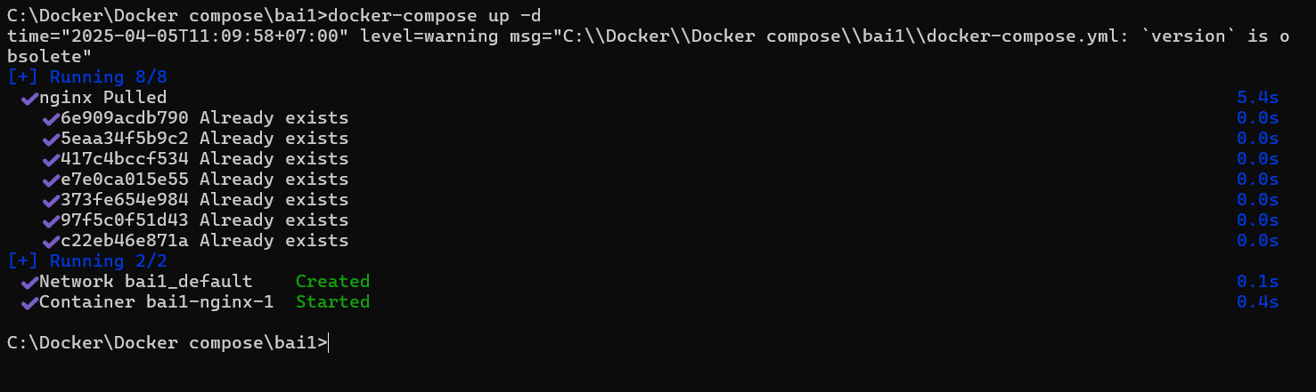

Kết quả

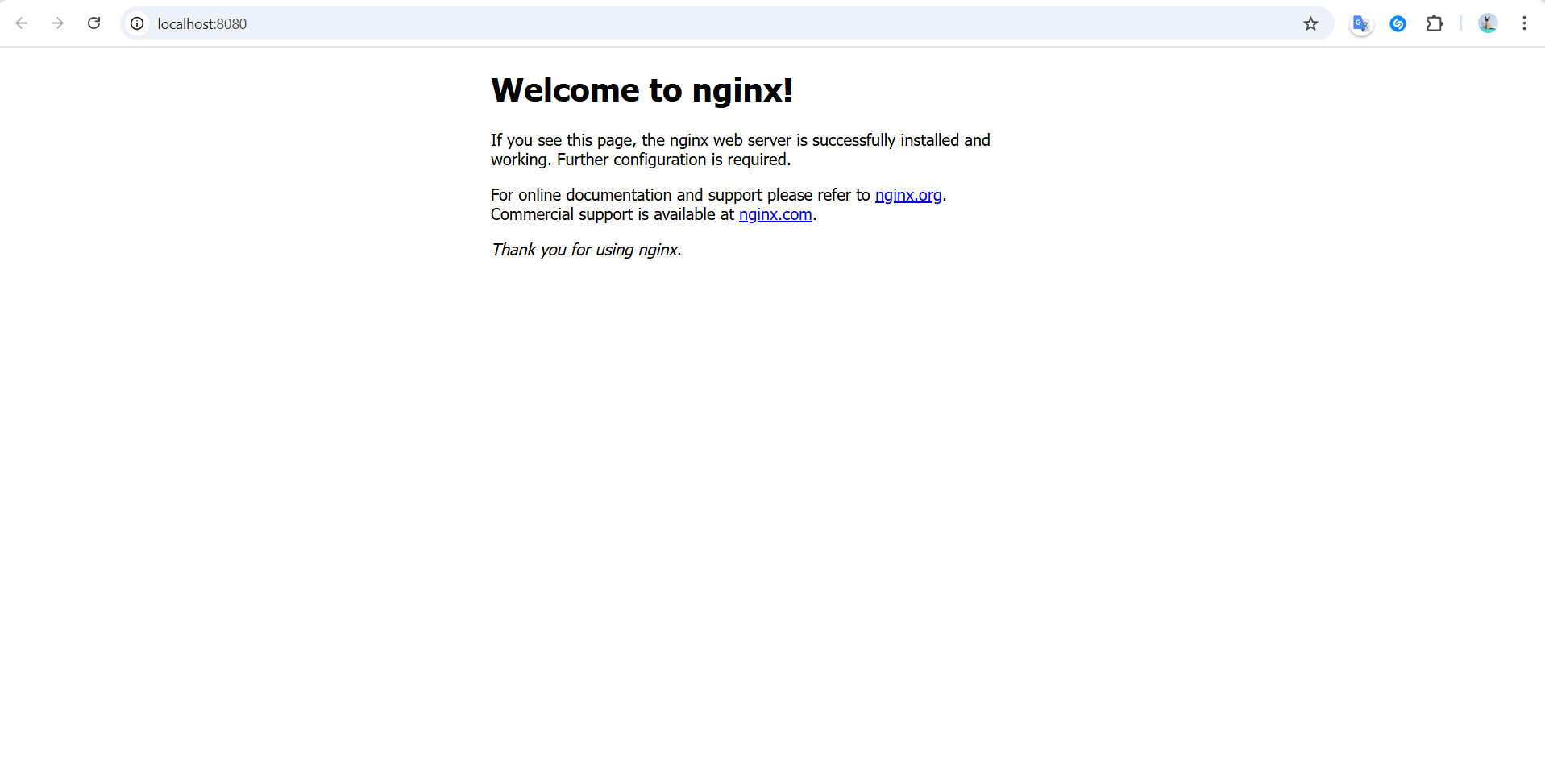

# ***Bài 2:***

**Tạo file docker-compose.yml**

version: '3'

services:

mysql:

image: mysql:8.0

command: --default-authentication-plugin=mysql_native_password

environment:

MYSQL_DATABASE: mydb

MYSQL_USER: user

MYSQL_PASSWORD: password

MYSQL_ROOT_PASSWORD: root

ports:

- "3307:3306"

**Thực hiện**

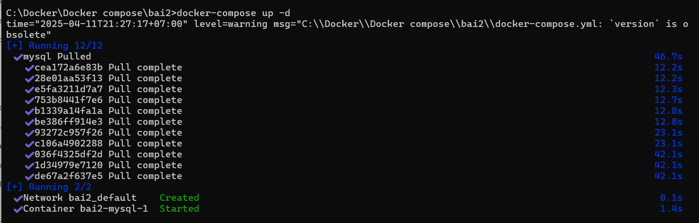

**Kết quả (Nhập password)**

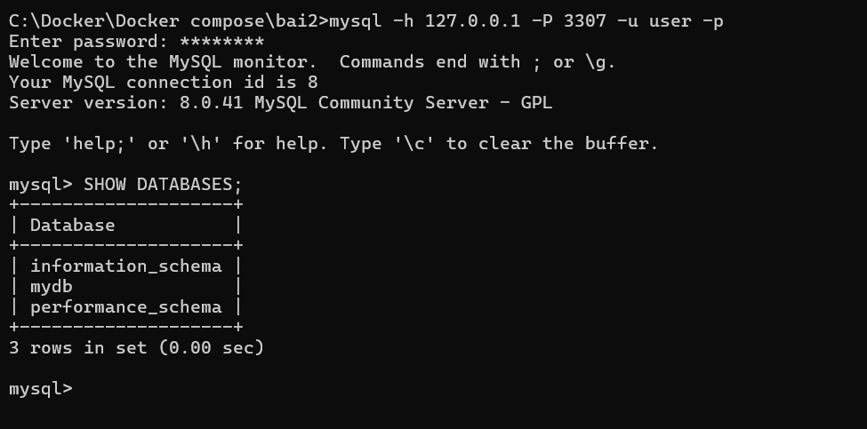

# ***Bài 3:***

**Tạo file docker-compose.yml**

version: '3'

services:

mysql:

image: mysql:8.0

environment:

MYSQL_ROOT_PASSWORD: root

MYSQL_DATABASE: mydb

MYSQL_USER: user

MYSQL_PASSWORD: password

ports:

- "3306:3306"

phpmyadmin:

image: phpmyadmin/phpmyadmin

environment:

PMA_HOST: mysql

PMA_USER: user

PMA_PASSWORD: password

ports:

- "8081:80"

Thực hiện

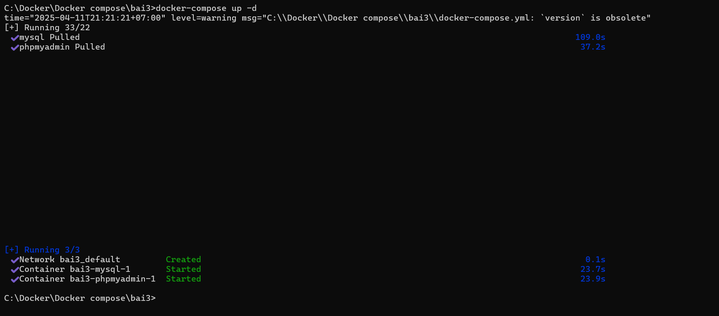

Kết quả

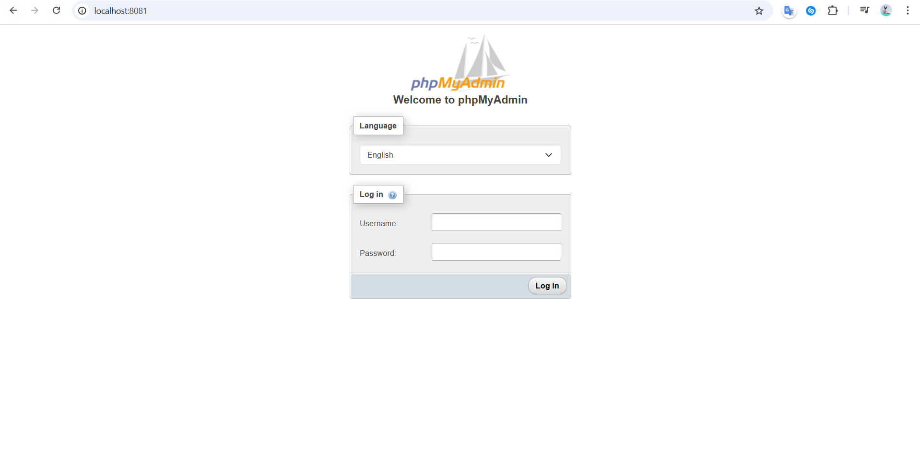

(Nhập user & password)

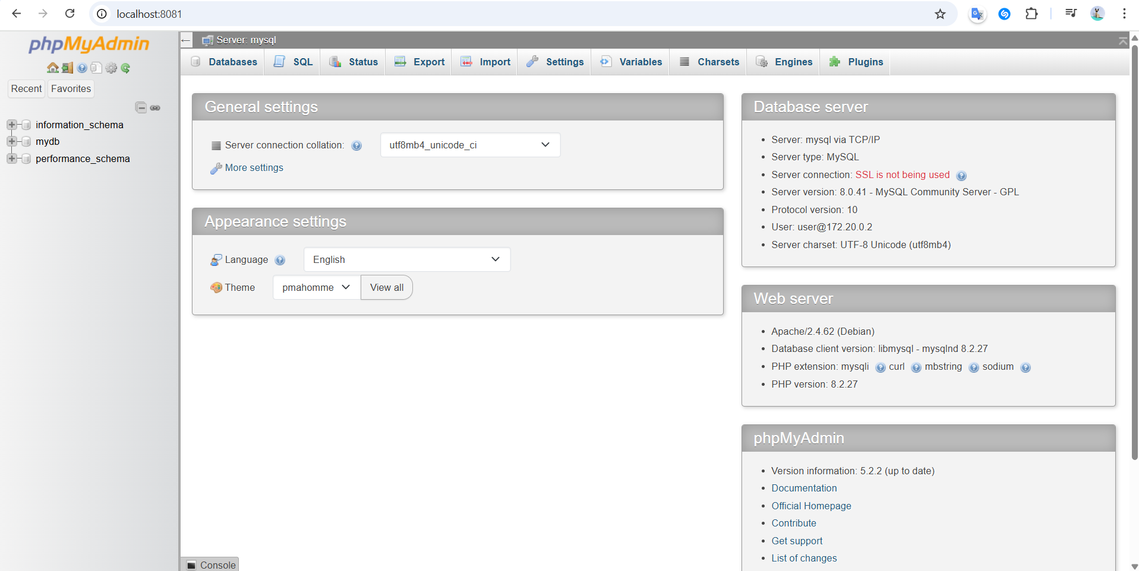

# ***Bài 4:***

***Tạo các file***

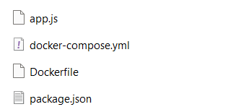

**Docker-compose.yml**

version: '3'

services:

node-app:

build: .

ports:

- "3000:3000"

**Dockerfile**

FROM node:16

WORKDIR /app

COPY package*.json ./

RUN npm install

COPY . .

CMD ["node", "app.js"]

**App.js**

const express = require('express');

const app = express();

app.get('/', (req, res) => res.send('Hello from Node.js'));

app.listen(3000, () => console.log('Server running on port 3000'));

**package.json**

{

"name": "node-docker",

"version": "1.0.0",

"main": "app.js",

"dependencies": {

"express": "^4.18.2"

}

}  
**Thực hiện**

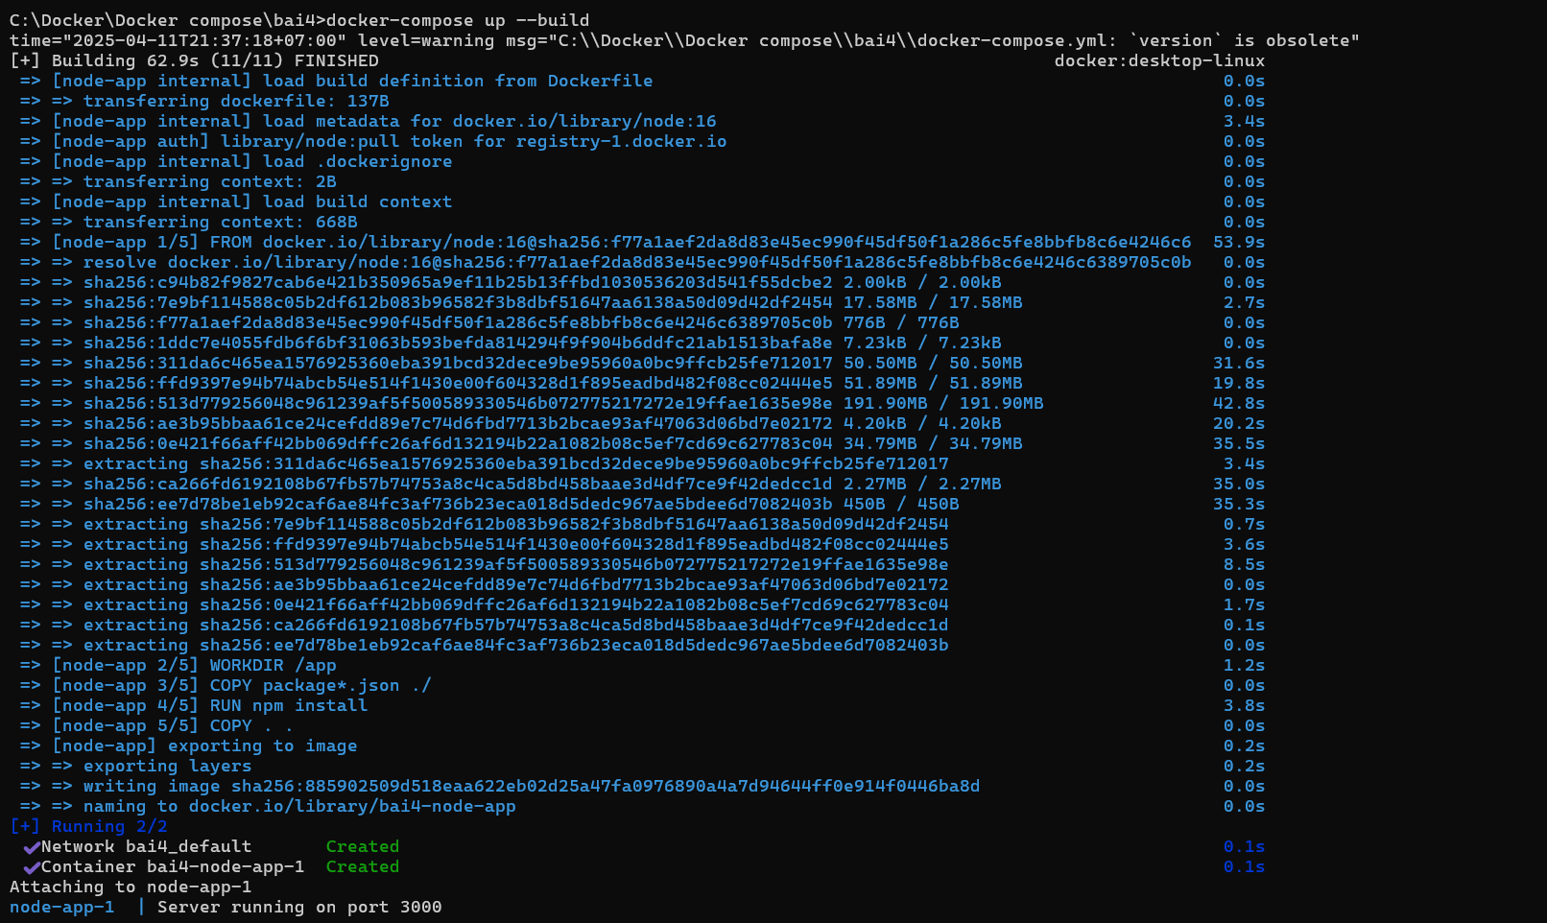

**Kết quả**

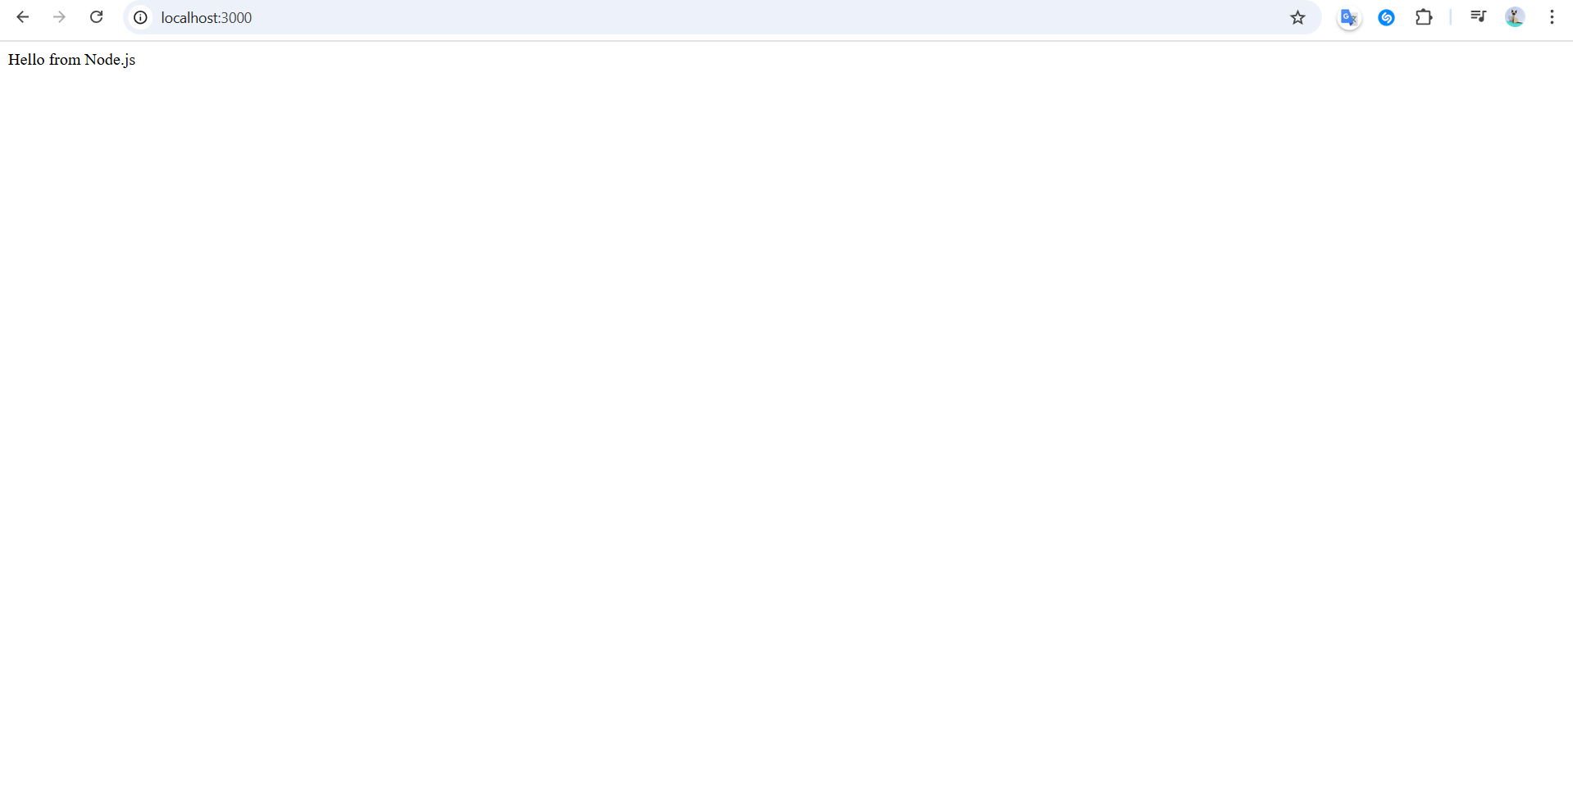

# ***Bài 5:***

**Tạo file docker-compose.yml**

version: '3'

services:

redis:

image: redis

ports:

- "6379:6379"

**Thực hiện**

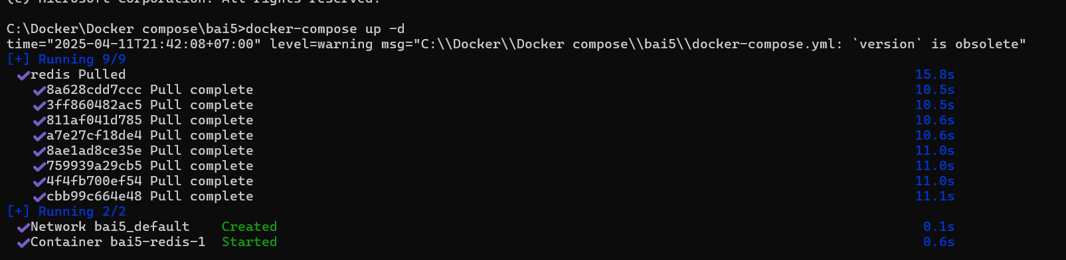

**Kết quả**

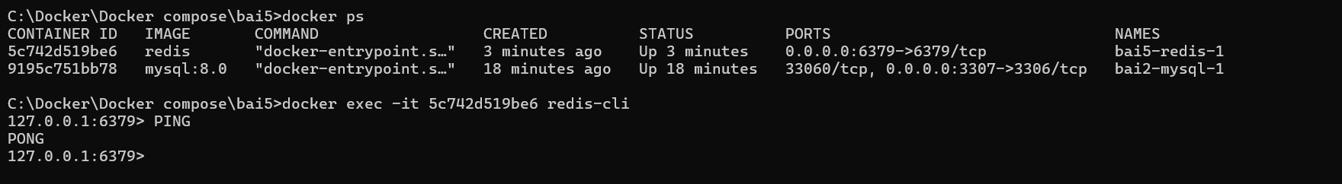

# ***Bài 6:***

**Tạo file docker-compose.yml**

version: '3'

services:

db:

image: mysql:5.7

environment:

MYSQL_DATABASE: wordpress

MYSQL_USER: user

MYSQL_PASSWORD: password

MYSQL_ROOT_PASSWORD: root

volumes:

- db_data:/var/lib/mysql

wordpress:

image: wordpress:latest

ports:

- "8080:80"

environment:

WORDPRESS_DB_HOST: db:3306

WORDPRESS_DB_USER: user

WORDPRESS_DB_PASSWORD: password

WORDPRESS_DB_NAME: wordpress

volumes:

db_data:

**Thực hiện**

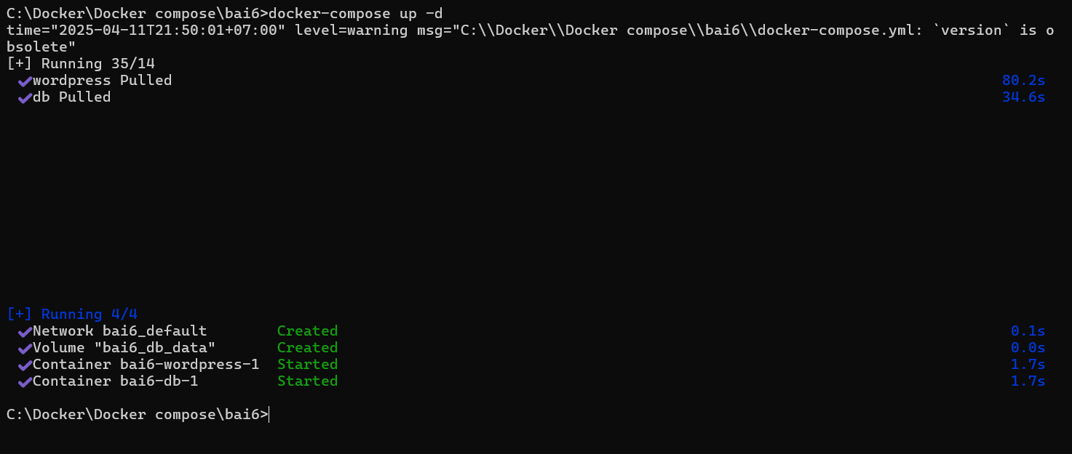

**Kết quả**

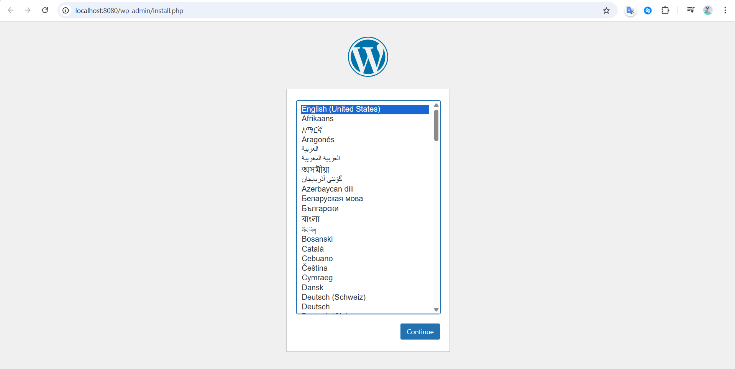

# ***Bài 7:***

**Tạo file docker-compose.yml**

version: '3'

services:

mongo:

image: mongo

ports:

- "27017:27017"

command: mongod --noauth # Tắt xác thực MongoDB

mongo-express:

image: mongo-express

ports:

- "8082:8081"

environment:

ME_CONFIG_MONGODB_SERVER: mongo

ME_CONFIG_BASICAUTH: "false" # Tắt xác thực UI mongo-express

**Thực hiện**

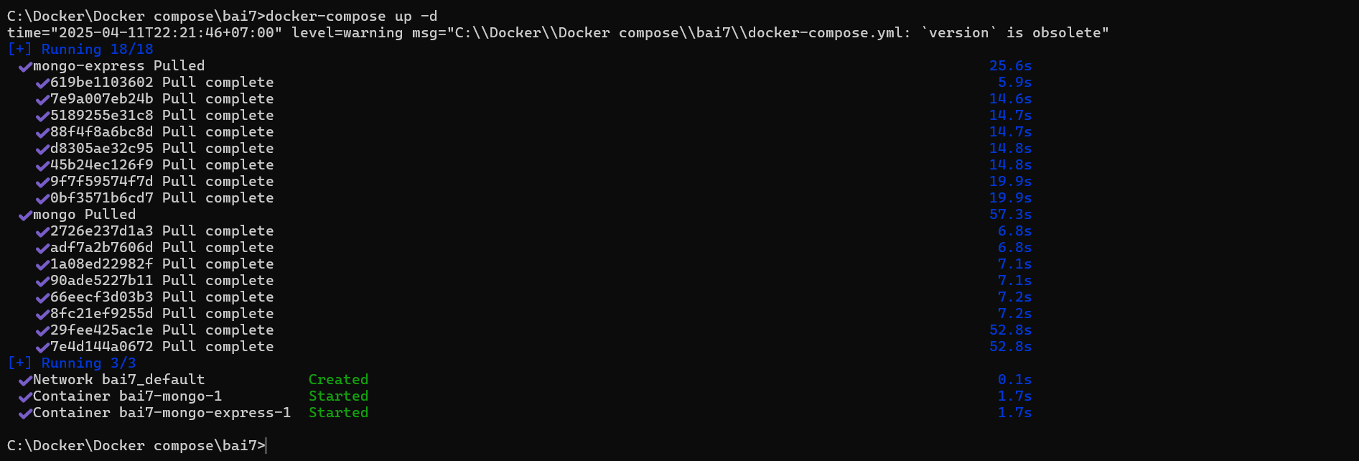

**Kết quả**

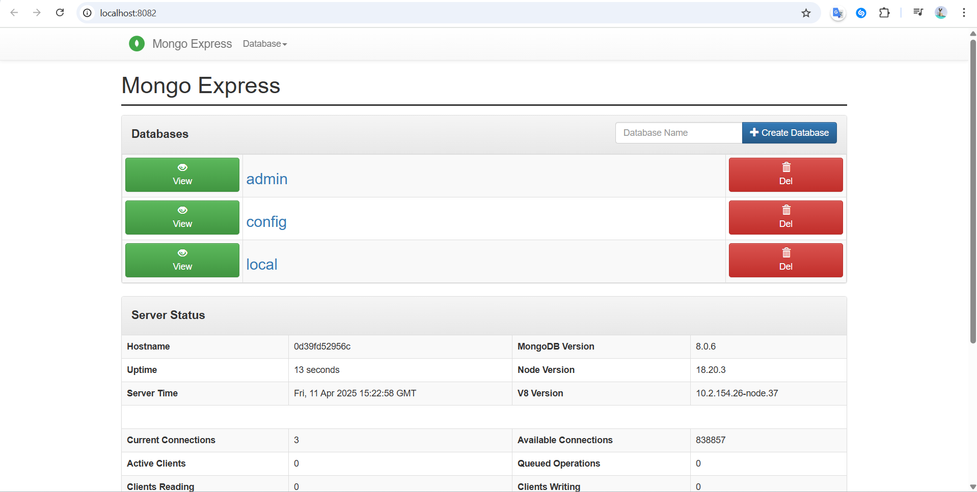

# ***Bài 8:***

**Tạo file docker-compose.yml**

version: '3.8'

services:

app:

build: ./app

ports:

- "3000:3000"

depends_on:

- mysql

mysql:

image: mysql:8.0

command: --default-authentication-plugin=mysql_native_password

environment:

MYSQL_DATABASE: mydb

MYSQL_USER: user

MYSQL_PASSWORD: password

MYSQL_ROOT_PASSWORD: root

ports:

- "3306:3306"

**Tạo một app Node.js**

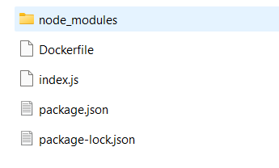

*Index.js*

const express = require('express');

const mysql = require('mysql2');

const app = express();

const port = 3000;

const connection = mysql.createConnection({

host: 'mysql', // tên service trong docker-compose

user: 'user',

password: 'password',

database: 'mydb'

});

connection.connect(err => {

if (err) {

console.error('MySQL connect error:', err);

return;

}

console.log('Connected to MySQL');

});

app.get('/', (req, res) => {

res.send('✅ Node.js connected to MySQL via Docker Compose!');

});

app.listen(port, () => {

console.log(`App listening at http://localhost:${port}`);

});

**Thực hiện**

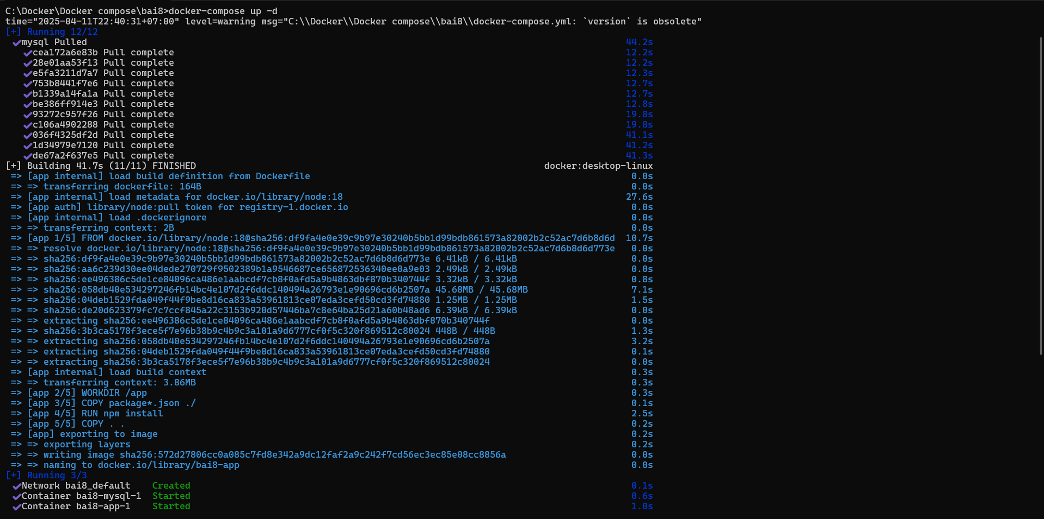

**Kết quả**

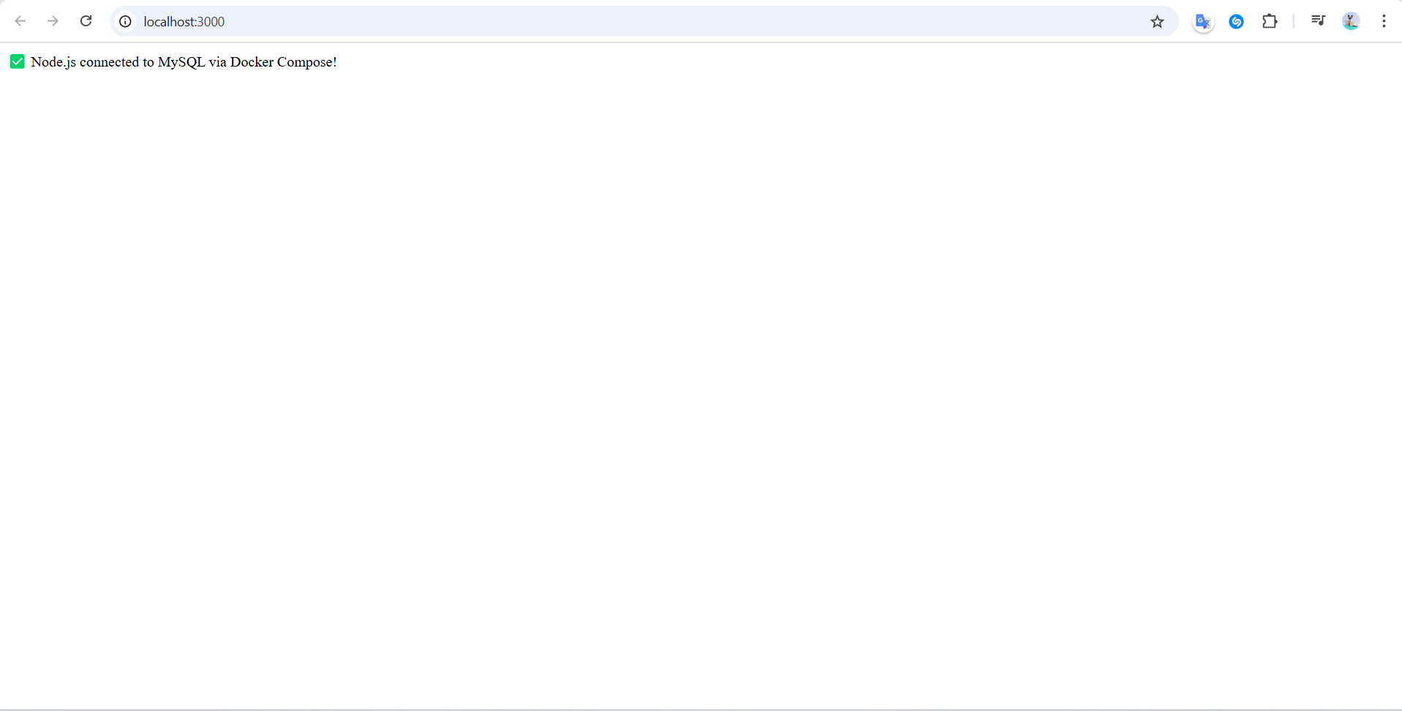

# ***Bài 9:***

**Tạo file docker-compose.yml**

version: '3.8'

services:

flask-app:

build: ./app

ports:

- "5000:5000"

**Tạo app**



*App.py*

from flask import Flask

app = Flask(__name__)

@app.route('/')

def hello():

return '✅ Hello from Flask inside Docker Compose!'

if __name__ == '__main__':

app.run(host='0.0.0.0', port=5000)

**Thực hiện**

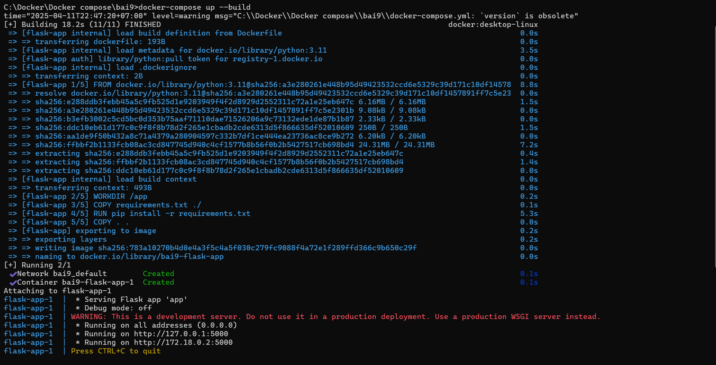

**Kết quả**

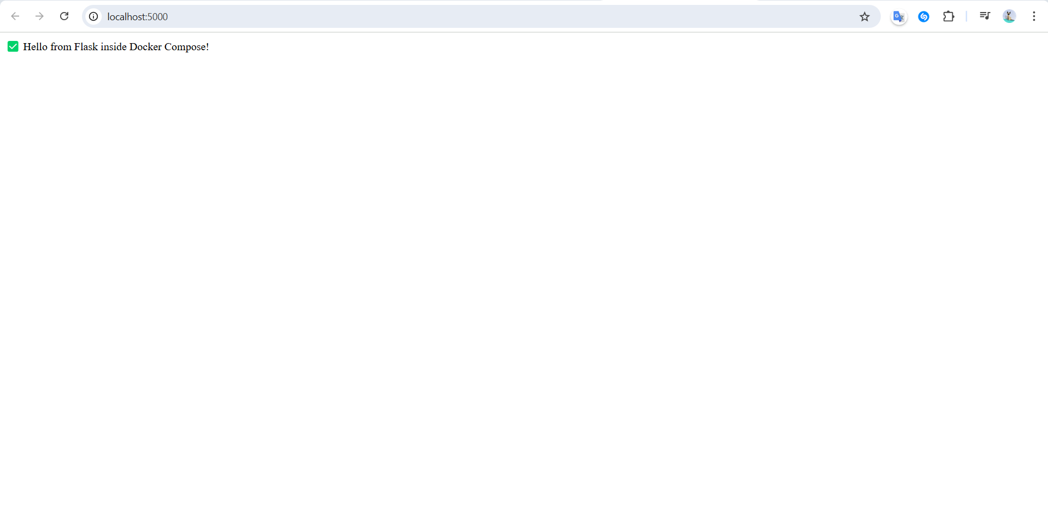

# ***Bài 10:***

**Tạo file docker-compose.yml**

services:

mysql:

image: mysql:8.0

ports:

- "3306:3306"

volumes:

- mysql_data:/var/lib/mysql

environment:

MYSQL_ROOT_PASSWORD: root

volumes:

mysql_data:

**Thực hiện**

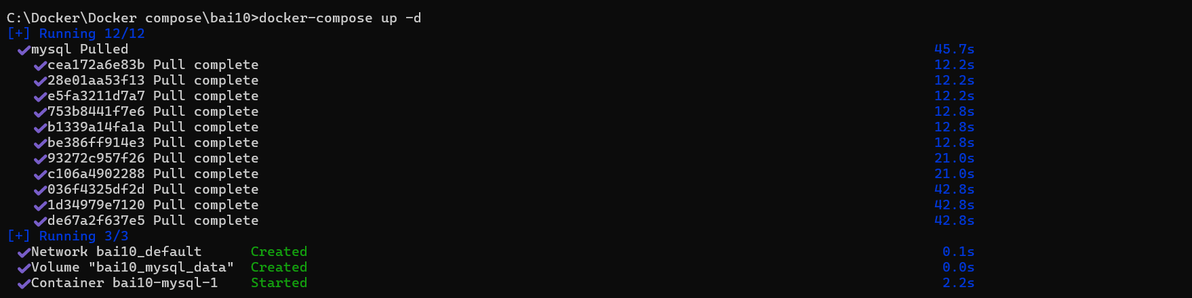

**Kết quả**

*Đầu tiên tạo users có 1 giá trị là 1 Alice*

**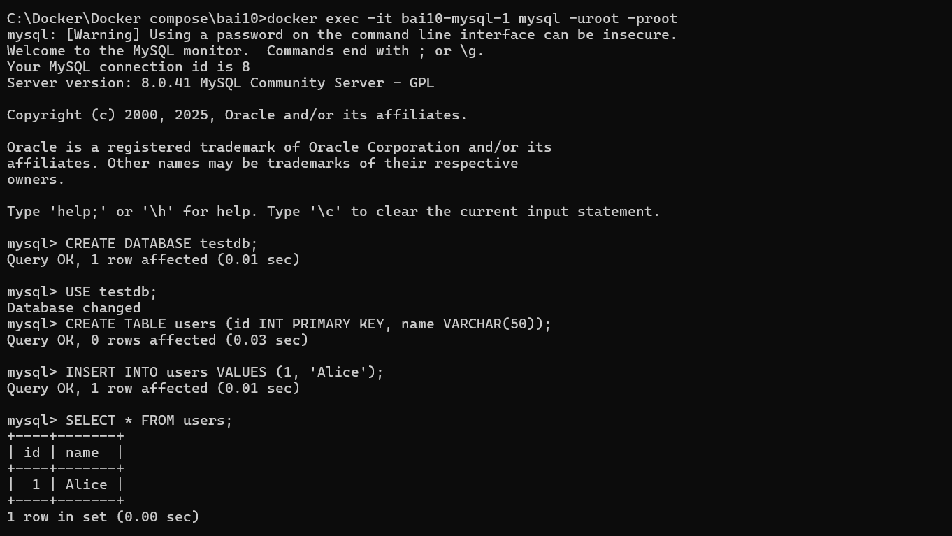  
Sau đó xóa (không dùng -v vì sẽ xóa volumn). Kết quá nhận được là vẫn còn 1 Alice**

